MVC’s New Health Outcome Variation Measure: What to Know
Video Transcript

Introduction
Scoring for the MVC Component of the BCBSM P4P Program will include a new health outcome variation measure beginning in Program Years 2026-2027 focused on benchmarking variation in health outcomes. MVC is here to support hospitals in understanding this new measure and collaborating to improve healthcare outcomes for all Michigan patients.

Why add this measure?
MVC's vision of sustainable, high-value healthcare requires that we reduce gaps in care and optimize outcomes for all patients.
PY 2025 mid-year scorecards included a preview of this measure for learning purposes with no points tied to it. In PYs 2026 and 2027, the measure will be fully implemented and scored for a total of 1.0 points. MVC will measure outcome variation using an index of variation.

What is the Index of Variation* (IOV)?
The IOV is a measure indicating the magnitude of differences for a specific risk-adjusted outcome between a hospital's patient subgroups compared to the overall hospital average. MVC will calculate a hospital’s IOV based on that hospital’s overall risk-adjusted readmission rate compared to their payer-specific readmission rates.
The target: A lower IOV represents a smaller spread of risk-adjusted all-cause readmission rates across payers at that hospital. If a hospital’s average readmission rates are identical across all payers, their IOV will be zero. Hospitals looking to lower their IOV can use MVC data to determine which patient groups have higher relative readmission rates and implement strategies to reduce preventable readmissions within that subgroup.
The payer groups: BCBSM and BCN Commercial, BCBSM and BCN Medicare Advantage, Medicare FFS only, Medicaid only, and Dual-Eligible

The IOV in action
Spread of Payer-Specific Readmission Rates
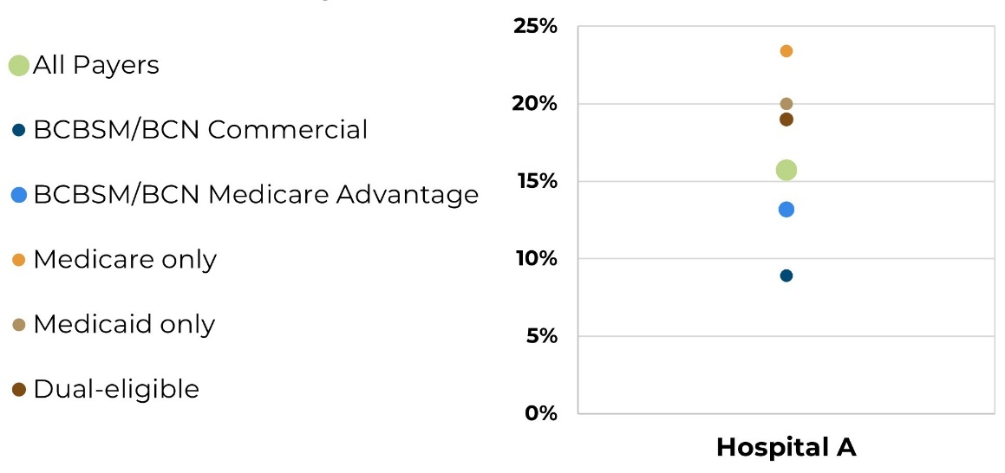
The IOV is also weighted to factor in the size of each payer-specific population.

What does success look like?
Hospitals can earn one P4P point in PYs 2026-2027 by either:
Achievement: A hospital’s IOV in the performance year is at or below the collaborative-wide median IOV, or
Improvement: A hospital’s IOV value decreases at least 10% from baseline year to performance year.

Closing
We are here to help with any questions about this new measure and look forward to collaborating with you! Together, we can reduce gaps in outcomes for patients in Michigan.
*IOV method references:
- CDC Fact Sheet: Health Disparity Measures
- American Journal of Public Health
- American Journal of Epidemiology
- Public Health Reports
- JCO Clinical Cancer Informatics
- Children and Youth Services Review

