MVC Hospitals and Physician Organizations
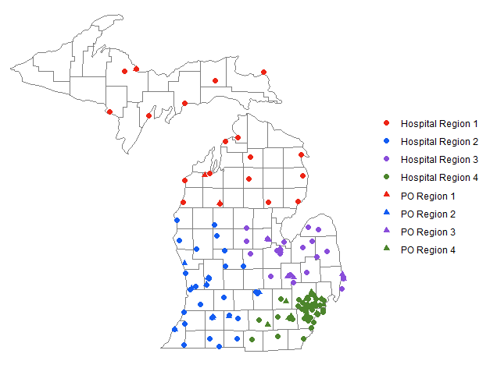

List of MVC Hospitals and Regions
MVC Region | Hospital Name
1 | Eaton Rapids Medical Center
1 | Helen Newberry Joy Hospital
1 | Mackinac Straights Health System
1 | Marshfield Medical Center - Dickinson
1 | McLaren Northern Michigan Hospital
1 | Munson Healthcare Cadillac Hospital
1 | Munson Healthcare Charlevoix Hospital
1 | Munson Healthcare Grayling Hospital
1 | Munson Healthcare Manistee Hospital
1 | Munson Healthcare Otsego Memorial Hospital
1 | Munson Healthcare Paul Oliver Memorial Hospital
1 | Munson Medical Center
1 | MyMichigan Medical Center - Alpena
1 | MyMichigan Medical Center - Sault
1 | MyMichigan Medical Center - Standish
1 | MyMichigan Medical Center - Tawas
1 | MyMichigan Medical Center - West Branch
1 | OSF St. Francis Hospital and Medical Group
1 | Schoolcraft Memorial Hospital
1 | UP Health System - Bell
1 | UP Health System - Marquette

List of MVC Hospitals and Regions, Cont.
MVC Region | Hospital Name
2 | Ascension Borgess Allegan Hospital
2 | Ascension Borgess Hospital
2 | Ascension Borgess Lee
2 | Beacon Health System Three Rivers Health Hospital
2 | Bronson Battle Creek Hospital
2 | Bronson LakeView Hospital
2 | Bronson Methodist Hospital
2 | Bronson South Haven Hospital
2 | Corewell Health Big Rapids Hospital
2 | Corewell Health Gerber Hospital
2 | Corewell Health Grand Rapids Hospital
2 | Corewell Health Greenville Hospital
2 | Corewell Health Lakeland Hospitals
2 | Corewell Health Ludington Hospital
2 | Corewell Health Pennock Hospital
2 | Corewell Health Reed City Hospital
2 | Corewell Health Watervliet Hospital
2 | Corewell Health Zeeland Hospital
2 | Holland Hospital
2 | Insight Coldwater Regional Hospital
2 | McLaren Greater Lansing Hospital
2 | Oaklawn Hospital
2 | Trinity Health Grand Haven Hospital
2 | Trinity Health Grand Rapids Hospital
2 | Trinity Health Muskegon Hospital
2 | University of Michigan Health – Sparrow Carson
2 | University of Michigan Health – Sparrow Clinton
2 | University of Michigan Health – Sparrow Eaton
2 | University of Michigan Health – Sparrow Ionia
2 | University of Michigan Health – Sparrow Lansing
2 | University of Michigan Health – West

List of MVC Hospitals and Regions, Cont.
MVC Region | Hospital Name
3 | Covenant Medical Center
3 | Henry Ford Health Genesys Hospital
3 | Henry Ford Health River District Hospital
3 | Hills and Dales General Hospital
3 | Hurley Medical Center
3 | Lake Huron Medical Center
3 | Marlette Regional Hospital
3 | McKenzie Health System
3 | McLaren Bay Region Hospital
3 | McLaren Caro Region Hospital
3 | McLaren Central Michigan Hospital
3 | McLaren Flint Hospital
3 | McLaren Lapeer Region Hospital
3 | McLaren Port Huron Hospital
3 | McLaren Thumb Region Hospital
3 | Memorial Healthcare
3 | MyMichigan Medical Center – Alma
3 | MyMichigan Medical Center – Clare
3 | MyMichigan Medical Center – Midland
3 | MyMichigan Medical Center – Saginaw
3 | Scheurer Health
3 | Scheurer Health- Harbor Beach Community Hospital

List of MVC Hospitals and Regions, Cont.
MVC Region | Hospital Name
4 | Chelsea Hospital
4 | Corewell Health Beaumont Grosse Pointe Hospital
4 | Corewell Health Beaumont Troy Hospital
4 | Corewell Health Dearborn Hospital
4 | Corewell Health Farmington Hills Hospital
4 | Corewell Health Taylor Hospital
4 | Corewell Health Trenton Hospital
4 | Corewell Health Wayne Hospital
4 | Corewell Health William Beaumont University Hospital (Royal Oak)
4 | DMC Detroit Receiving Hospital & University Health Center
4 | DMC Harper/Hutzel Hospital
4 | DMC Huron Valley Sinai Hospital
4 | DMC Sinai Grace Hospital
4 | Garden City Hospital
4 | Henry Ford Health Henry Ford Hospital
4 | Henry Ford Health Jackson Hospital
4 | Henry Ford Health Macomb Hospital
4 | Henry Ford Health Madison Heights – Warren Hospital
4 | Henry Ford Health Providence Novi – Southfield Hospital
4 | Henry Ford Health Rochester Hospital
4 | Henry Ford Health St. John Hospital
4 | Henry Ford Health West Bloomfield Hospital
4 | Henry Ford Health Wyandotte Hospital
4 | Hillsdale Community Health Center
4 | McLaren Macomb Hospital
4 | McLaren Oakland Hospital
4 | Michigan Medicine
4 | ProMedica Charles and Virginia Hickman Hospital
4 | ProMedica Monroe Regional Hospital
4 | Trinity Health Ann Arbor Hospital
4 | Trinity Health Livingston Hospital
4 | Trinity Health Livonia Hospital
4 | Trinity Health Oakland Hospital

List of MVC Physician Organizations and Regions
MVC Region | PO Name
1 | Northern Michigan Care Partners
1 | Novello Physicians Organization (NPO)
1 | Upper Peninsula Health Group
2 | Answer Health Physician Organization
2 | Bronson Network LLC
2 | Corewell Health Medical Group South
2 | Corewell Health Medical Group West
2 | Holland PHO
2 | Integrated Health Partners
2 | Metro Health Integrated Network
2 | MSU Health Care
2 | Trinity Health Alliance of Michigan
2 | University of Michigan Health - Sparrow Care Network
3 | Genesys PHO LLC
3 | Great Lakes OSC, LLC
3 | Lake Huron PHO
3 | MyMichigan Collaborative Care Organization
3 | Physician Healthcare Network, PC
3 | Primary Care Partners, Inc
3 | Professional Medical Corporation, PC
3 | St. Mary's PHO, LLC

List of MVC Physician Organizations and Regions, Cont.
MVC Region | PO Name
4 | Aledade ACO
4 | Consortium of Independent Physician Associations (CIPA)
4 | Corewell Health Medical Group East
4 | GMP Network
4 | Henry Ford Medical Group
4 | Huron Valley Physicians Assoc, P.C.
4 | Jackson Health Network, L3C
4 | Livingston Physician Organization (LPO), LLC
4 | McLaren Physician Partners
4 | Medical Network One
4 | Oakland Physician Network Services
4 | Oakland Southfield Physicians
4 | Olympia Medical, LLC
4 | The Physician Alliance, LLC
4 | Trinity Health IHA Medical Group
4 | United Physicians, Inc
4 | University of Michigan Health System
4 | Wayne State University Physician Group

